FloodKit® FloodFoam®
FloodFoam® is Soft Spongy closed cell expanding foam that creates a water barrier that springs back – recovers when compressed making it ideal for sealing purposes. It also has acoustic properties to 60db
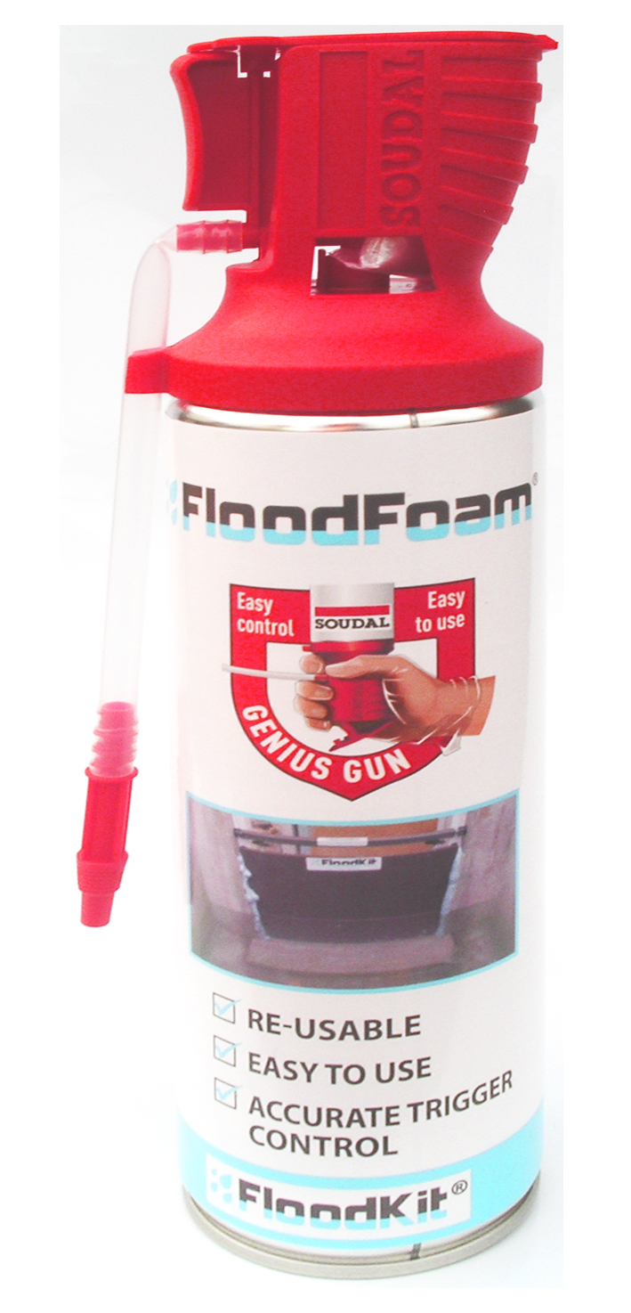

Supplied in the Genius Gun Can it is a one-component, self-expanding, ready to use polyurethane foam without the need for separate applicators. The product has minimal expansion after application (less than 50%) and is therefore very economical to use.
FloodKit® FloodFoam® is much more elastic than standard PU-foam: and has a very high Acoustic Rating value.
Elastic Recovery (ISO 1856) is up to 90% if the foam is compressed by 75%.
Note: Traditional PU-foam does not have any recovery if the compression is higher than 10%.
Elongation at break is 3 x that of traditional foam. The maximum elongation before breaking (DIN 18540) is about 45% compared to 15% for traditional PU-foam.
FloodFoam® follows the movements of the joint and retains its insulating properties over the years, especially in smaller joints (e.g. 2 to 3 cm wide). The maximum movement allowed for traditional builders foam before breaking is only 2mm for compression or 3mm elongation and after several years this will reduce by up to 50%. Therefore joint movements will eventually cause a traditional ‘builders expanding foam’ to breakup or shear allowing water to enter.
Due to the flexibility and elasticity properties FloodFoam® maintains its characteristics much better over time.
Inbuilt gun comes complete with cap to seal nozzle so can be used for up to 3 weeks after first use.

ASPLI SAFETY LTD.
209/211 HUNSLET ROAD, LEEDS, LS10 1PF.
TEL: 0113 2461 550 FAX: 0113 2461 560
E-Mail: sales@aspli.com www.aspli.com

